First Reconciliation
and
First Eucharist

Parent Handbook
2025-2026

Our Lady of Good Counsel Parish
Moorestown, New Jersey

First Reconciliation / First Eucharist Team

The Parents of all our communicants

Bishop David O’Connell, CM Bishop of Trenton

Father Jim Grogan, Sr. Pastor

Father Jack Bogacz Associate

Deacon Edward Heffernan Deacons
Deacon John Bertagnolli
Deacon Thomas Kolon
Deacon Thomas D. Begley III
Deacon Stuart Altschuler

Mrs. Cynthia Robinson Parish Catechetical Leader

Mrs. Cynthia Smith Principal, Our Lady of Good Counsel School

Dr. Veronica Lye Sacred Music Ministry

Mrs. Danielle Meosky Office Manager / Registrar

Ms. Sandra Prokop OLGC School Teachers
Mrs. Stephanie Tobin

Mrs. Christine Bradley Catechists
Mrs. Tracey Coffen
Mrs. Allison Collins
Mrs. Bryannah Janota
Mrs. Christine Mansfield
Mrs. Molly Mills

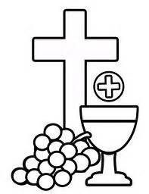

First Reconciliation / First Eucharist Program

Diocese of Trenton Guidelines

- First Reconciliation
- First Eucharist

First Reconciliation:

- Parent Participation
- Sacrament of Reconciliation Format
- Sacrament of Reconciliation

First Eucharist:

- Parent Participation
- Sacramental Register Form
- Sacrament of Eucharist Format
- Sacrament of Eucharist

Please contact the Office of Religious Education for questions and details regarding
First Reconciliation and First Eucharist

Mrs. Cynthia Robinson, Parish Catechetical Leader
Our Lady of Good Counsel, 122 West Main Street, Moorestown, NJ 08057
Phone: (856) 235-7136
E-mail: crobinson@olgc.me

Please visit our parish website for First Reconciliation and First Eucharist information:
www.olgcnj.org (Religious Education / Sacramental Preparation)

Diocese of Trenton Guidelines: First Reconciliation and First Eucharist

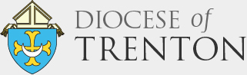

Before entering the immediate preparation for the Sacrament of Reconciliation and Eucharist, children should have a basic knowledge and understanding of the following:
(Grade 1 Curriculum)
- God, as Father, Son, and Holy Spirit
- God’s personal love for each person
- The Church as the People of God
- The Sacrament of Baptism
- Prayer as a response to God’s love
- Traditional Prayers: Our Father, Hail Mary, Sign of the Cross, and Act of Contrition

Immediate preparation for First Reconciliation will include the following concepts:
(Grade 2 Curriculum)
- The Two Great Commandments – Love God and others
- Sin as a refusal to love God, others, and ourselves
- God is always ready to forgive us
- It is within the Church, God’s family, that we publicly acknowledge God’s forgiveness through the Sacrament of Reconciliation
- Understanding the meaning of the sacramental encounter with Jesus
- Helping children look at their choices – not only their actions, but the attitudes behind their actions
- Knowing how to receive the Sacrament and be able to articulate an Act of Contrition
- Experience the Sacrament of Reconciliation as a prayerful experience
- Informing the children and parents that the Sacrament may be celebrated differently in other parishes and in other settings so that they will be comfortable celebrating the sacrament wherever they may be.
(Diocese of Trenton: Parish Religious Education Administration Manual: First Reconciliation: 406: Policy, A, B, C, November 2012)

Immediate preparation for First Eucharist will include the following concepts:
(Grade 2 Curriculum)
- To know who Jesus is and the main events of His life
- To realize that Jesus is present in the Eucharistic Bread and Wine
- Understanding the meaning of the sacramental encounter with Jesus
- To indicate a desire to receive the Eucharist
- Knowing how to receive the Sacrament
- Experience the Sacrament of Eucharist as a prayerful experience
- Informing the children and parents that the Sacrament may be celebrated differently in other parishes and in other settings so that they will be comfortable celebrating the sacrament wherever they may be.
(Diocese of Trenton: Parish Religious Education Administration Manual: First Eucharist: 407: Policy, A, B, C, November 2012)

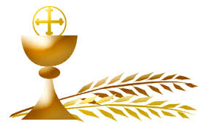

First Reconciliation

Parent Participation

As primary catechists, parents have an active roll in their child’s preparation for First Reconciliation.

Assessment of Child’s Readiness
First Communicants should have a good understanding that in the Sacrament of Reconciliation we express sorrow to God for our sins and are forgiven.

Preparation for the Celebration of First Reconciliation
- Children are provided with First Reconciliation workbooks. Parents are encouraged to work with their child in reviewing and discussing the material.
- Parents are asked to review the Examination of Conscience and Format for Reconciliation (found in this handbook) with their child.
- Parents are encouraged to discuss and share stories of Jesus with the child – especially those pertaining to forgiveness (The Forgiving Father, The Lost Sheep, Zacchaeus, etc).

Sacrament of First Reconciliation

First Reconciliation is celebrated on various dates prior to First Eucharist.

Date | Time | Class
Tuesday, November 4, 2025 | 7 pm | RE Summer and Homes Study
Wednesday, November 12, 2025 | 7 pm | OLGC School – 2A and 2B
Tuesday, November 18, 2025 | 7 pm | RE Monday and Tuesday

**Please note: No penitential service or confession shall be recorded, photographed, or videotaped.
Diocese of Trenton: Celebration of the Sacraments: Policy: 404

Sacrament of Reconciliation Format

This hand helps me to remember what I need to do to receive the Sacrament of Reconciliation.

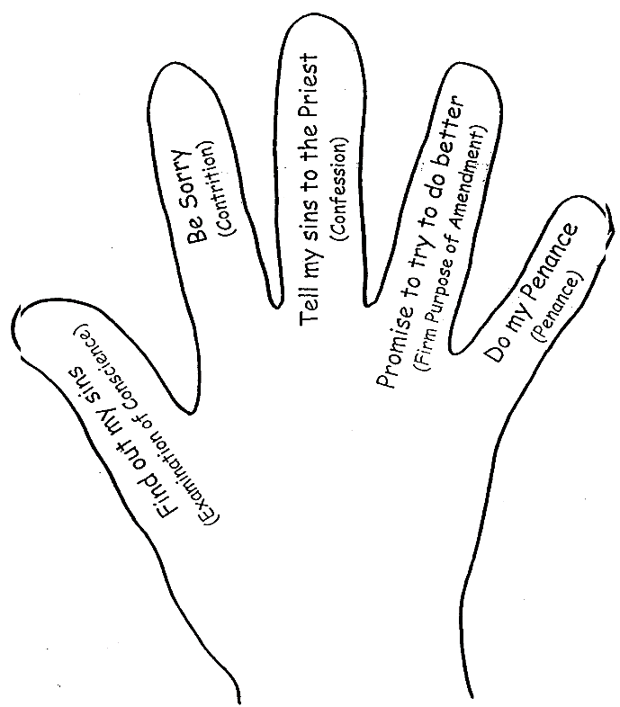

Format for Reconciliation:

You say: Bless me Father, for I have sinned.
This is my first confession or It has been __since my last confession.
Father, I…..

Priest says: For your penance…..
(for example: say one Our Father or help your parents today)

You say: Act of Contrition
O my God, I am sorry for my sins.
In choosing to sin, and failing to do good,
I have sinned against you and your church.
I firmly intend, with the help of your Son,
To make up for my sins, and to love as I should.

Priest says: I absolve you of your sins, in the name of the Father,
and of the Son, and of the Holy Spirit. God bless you.

You say: Thank you Father and God bless you.

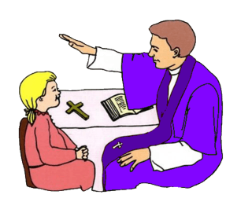

First Eucharist

Parent Participation

As primary catechists, parents have an active roll in their child’s preparation for First Eucharist. This includes:

Assessment of Child’s Readiness
First Communicants should have a good understanding that at Mass the bread and wine become
the Body and Blood of Jesus.

Preparation for the Celebration of First Eucharist
- Children are provided with First Eucharist workbooks. Parents are encouraged to work with their child in reviewing and discussing the material.
- The child should be participating in weekly Mass for a better understanding of liturgy, preparation for Eucharist, and community involvement.
- Parents are asked to review the format for receiving the host with their child (found in this handbook) and the responses.
- Parents are encouraged to discuss and share stories of Jesus with their child – especially those pertaining to Eucharist (Wedding Feast of Cana, Loaves and Fishes, Last Supper).

Please note:
Immediate preparation for Eucharist includes children being given unconsecrated hosts during class time and at special practices.
Parents are asked to notify the Religious Education Office of any known gluten or related allergies.

First Eucharist Dates

Date | Liturgy
Saturday, April 25, 2026 | 10am – RE Summer and Homes Study  12noon - OLGC School – 2A and 2B
Saturday, May 2, 2026 | 10am – RE Monday  12noon – RE Tuesday

Sacrament of Eucharist Format

When it is time to receive communion, I step in to the aisle with my hands folded in prayer.

I form a line called a “communion procession”. I am reverent as I approach the altar.

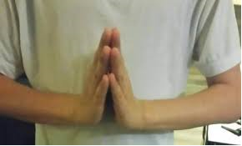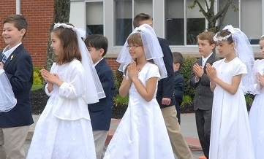

When I reach the priest / minister, they will hold up the consecrated host and say

“The Body of Christ”. I bow my head and respond “Amen”.

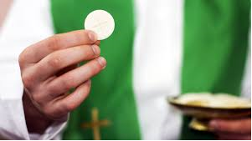

I make a table with my hands. The priest / minister places the host in my hands. With my bottom hand, I take the host and immediately place in my mouth.

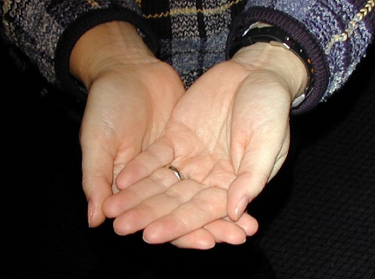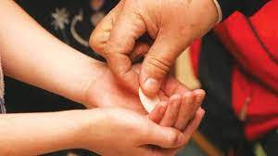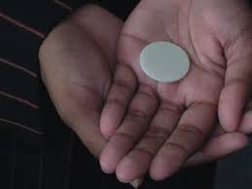

I return to my pew with my hands folded in prayer. I kneel and talk to Jesus for a few minutes.

I sit when the Tabernacle is closed.

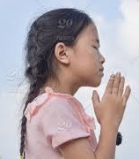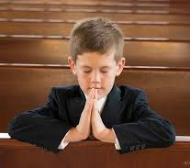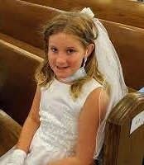

Details regarding First Reconciliation and First Eucharist

- Baptismal Certificate:
(Collected at registration.) A copy must be presented and verified before First Reconciliation and First Eucharist may be celebrated.

- First Communion Sacramental Register Form / Grade 2 Expenses Fee:
Submitted to RE Office through Parish Giving. The fee covers sacramental-related expenses, namely: First Reconciliation and First Eucharist workbooks, Mass books, parent handbook, liturgy booklets, gifts, certificates, and flowers.

- Liturgical Ministers:
We ask any family with an OLGC parish commissioned altar server or Eucharistic Minister who would like to participate in the liturgy to notify the RE Office by mid-January.

- Visiting Clergy:
Any family who has a priest or deacon family member who they would like to concelebrate the First Eucharist liturgy, or assist at First Reconciliation is asked to notify the Parish Office as soon as possible. Any clergy member outside of the Diocese of Trenton, is to present their Letter of Suitability to the Parish Office.

- Disability Seating:
Any family requiring disability seating are asked to contact the R.E. Office no later than mid-January, when Family Pews are assigned. Disability seating is assigned to accommodate guests with special needs, allow for distribution of the Eucharist, and to ensure fire codes regarding unblocked aisles are met. Staff members are available to assist families.

- Seating:
A family pew will be reserved for each child. We estimate 9 family members will fit comfortably, along with the child. Any guest who cannot be accommodated in the family pew will be invited to the general seating pews or the simulcast in the chapel. Due to fire codes, no one is permitted to stand in the aisles.

- Attire:
Boys wear suit jackets dress shirts, and tie, in the color of their choice. Girls usually wear white dresses. If gloves are worn, please have children remove after the procession.

- Reverence:
Families are expected to observe a reverent demeanor in church during all liturgies.

- Pictures:
  - Reconciliation: No penitential service or confession shall be recorded, photographed, or videotaped. Diocese of Trenton: Celebration of the Sacraments: Policy: 404
  - First Communion: Flash photography is not permitted. Only photograph your child without interrupting the flow of the liturgy. Pictures of children other than your own may not be posted to social media. Parents are asked to convey this policy to guests.

Catholic Prayers to Know

Sign of the Cross

In the name of the Father, and of the Son,

and of the Holy Spirit, Amen.

Our Father

Our Father, who art in heaven,

hallowed be thy name; thy kingdom come;

thy will be done on earth as it is in heaven.

Give us this day our daily bread;

and forgive us our trespasses

as we forgive those who trespass against us;

and lead us not into temptation,

but deliver us from evil. Amen.

Hail Mary

Hail Mary, full of grace, the Lord is with you!

Blessed are you among women,

and blessed is the fruit of your womb, Jesus.

Holy Mary, Mother of God, pray for us sinners,

now and at the hour of our death. Amen.

Act of Contrition
O my God, I am sorry for my sins.
in choosing to sin, and failing to do good.
I have sinned against you and your Church.
I firmly intend, with the help of your Son,
to make up for my sins and to love as I should.

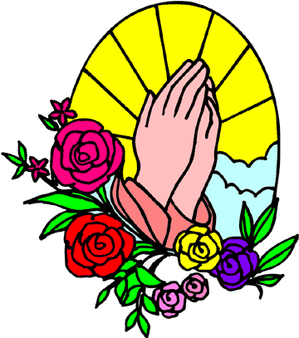

Parent Pledge of Commitment

I affirm my commitment to the Catholic Church
to be a supportive force in my child’s life
as I raise my child a Catholic.
Through my lived example,
my child shall be reminded that
I am the first and foremost catechist in the home.
Through me, my child shall come to understand
Catholic values and attitudes
by showing love for Christ and His Church.
Finally, I pledge to nurture the faith of my child
by faithfully attending Mass each week together,
by reverently receiving the Eucharist
and living in its spirit,
and by fostering justice and love
in all our relationships as a family.



